

VIVEKANANDA INSTITUTE OF PROFESSIONAL STUDIES - TECHNICAL CAMPUS
Grade A++ Accredited Institution by NAAC
NBA Accredited for MCA Programme; Recognized under Section 2(f) by UGC;
Affiliated to GGSIP University, Delhi; Recognized by Bar Council of India and AICTE
An ISO 9001:2015 Certified Institution

SCHOOL OF ENGINEERING & TECHNOLOGY
B.Tech Programme: Computer Science & Engineering

Course Title: Distributed Systems and
Cloud Computing Lab
Course Code: CIE-407P
Semester: 7th

Submitted By:

Name: Ishaan Jain
Enrollment No: 06117702722
Branch & Section: CSE-B



An ISO 9001:2015 Certified Institution
SCHOOL OF ENGINEERING & TECHNOLOGY

VIVEKANANDA INSTITUTE OF PROFESSIONAL STUDIES - TECHNICAL CAMPUS
Grade A++ Accredited Institution by NAAC
NBA Accredited for MCA Programme; Recognized under Section 2(f) by UGC;
Affiliated to GGSIP University, Delhi; Recognized by Bar Council of India and AICTE

VISION OF INSTITUTE

To be an educational institute that empowers the field of engineering to build a sustainable future by providing quality education with innovative practices that supports people, planet and profit.

MISSION OF INSTITUTE
To groom the future engineers by providing value-based education and awakening students' curiosity, nurturing creativity and building capabilities to enable them to make significant contributions to the world.


VIVEKANANDA INSTITUTE OF PROFESSIONAL STUDIES - TECHNICAL CAMPUS
Grade A++ Accredited Institution by NAAC
NBA Accredited for MCA Programme; Recognized under Section 2(f) by
UGC; Affiliated to GGSIP University, Delhi; Recognized by Bar Council of
India and AICTE An ISO 9001:2015 Certified Institution
SCHOOL OF ENGINEERING & TECHNOLOGY
INDEX
S.no | EXPERIMENT | Date | Marks |  |  | Remark | Updated Marks | Faculty Signature
 |  |  | Laboratory Assessment | Class Participation | Viva

EXPERIMENT - 1

AIM: Write a Program in Java to implement RPC

THEORY:

A Remote Procedure Call (RPC) is a protocol that allows a program on one computer (the client) to execute procedures (methods/functions) on another computer (the server) as if they were local.
It hides the complexity of network communication → the programmer just calls a method, and the underlying system handles message passing, marshalling, and network transport.

Key Characteristics
- Transparency: Client calls remote methods just like local ones.
- Language independent: RPC can work across different programming languages (via IDL – Interface Definition Language).
- Communication: Uses request–response over a network (TCP/UDP).
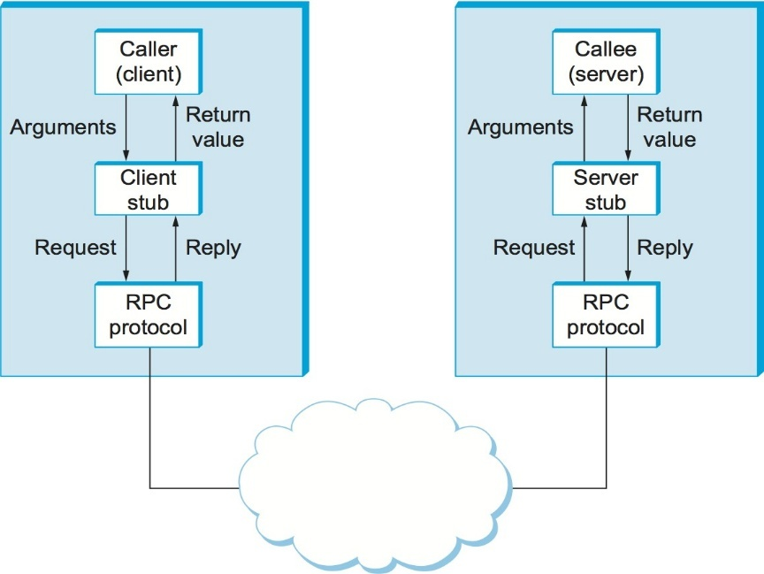
- Client-Server model: The client initiates, the server executes.

Architecture of RPC

Advantages

- Simplifies distributed computing.
- Hides details of network programming (no sockets needed for the user).
- Increases modularity (clients and servers can evolve separately).

Disadvantages

- Overhead: More expensive than local calls due to network latency.
- Partial failures: If the server or network fails, the client might hang or crash.
- Not transparent for non-functional aspects: E.g., performance, failures, and security issues are different from local calls.

CODE:

Server.java
package rpcpassword;

import java.net.*;
import java.io.*;

public class server {
public static void main(String[] args) { try (ServerSocket serverSocket = new ServerSocket(6000)) { System.out.println("\nServer listening on port 6000\n"); while (true) {
Socket clientSocket = serverSocket.accept(); new Thread(() -> {
try (BufferedReader in = new BufferedReader(new InputStreamReader(clientSocket.getInputStream())); PrintWriter out = new PrintWriter(clientSocket.getOutputStream(), true)) {

String request = in.readLine();
System.out.println("Received password from client: " + request);

if ("password123".equals(request)) { out.println("Access granted\n");
System.out.println("Access granted to client\n");
} else {
out.println("Access denied\n");
System.out.println("Access denied to client - incorrect password\n");
}

} catch (IOException e) {
System.err.println("Client error: " + e.getMessage());
}
}).start();
}
} catch (IOException e) {
System.err.println("Server error: " + e.getMessage());
}
}

}

Client.java
package rpcpassword;

import java.net.*; import java.io.*; import java.util.Scanner;

public class client {
public static void main(String[] args) {
try (Socket socket = new Socket("localhost", 6000)) {
PrintWriter out = new PrintWriter(socket.getOutputStream(), true);
BufferedReader in = new BufferedReader(new InputStreamReader(socket.getInputStream())); Scanner scanner = new Scanner(System.in);

System.out.print("\nEnter password: ");
String password = scanner.nextLine();

out.println(password);

String response = in.readLine();
System.out.println("Server response: " + response);

scanner.close(); } catch (IOException e) { System.err.println("Client error: " + e.getMessage());
}
}
}

OUTPUT:

Server
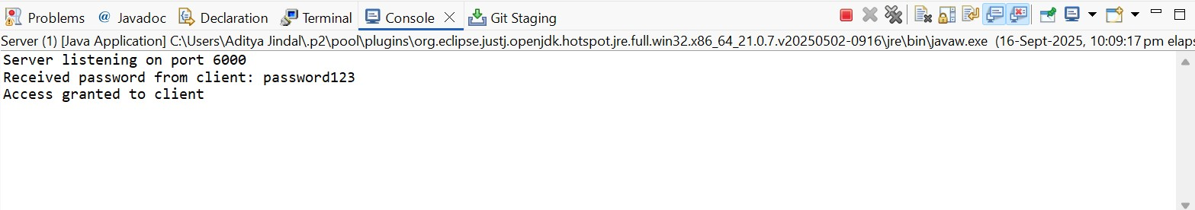

Client
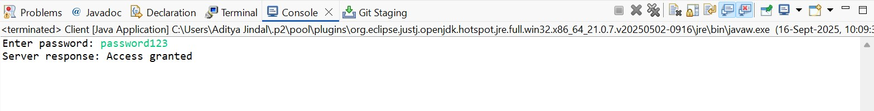

LEARNING OUTCOME:

EXPERIMENT - 2

AIM: Implement the concept of Remote Method Invocation in Java.

THEORY:
Remote Method Invocation (RMI) is Java’s mechanism to implement Remote Procedure Calls (RPC) in an object-oriented way.
It allows a Java program running on one Java Virtual Machine (JVM) to invoke methods of an object running on another JVM, possibly on a different machine, as if the method were local.

Key Features
- Purely Java-based distributed computing.
- Provides location transparency: the client does not need to know where the object is running.
- Supports object serialization: allows passing complex objects (not just primitive data types) across the network.
- Built-in security manager and exception handling for remote operations.

RMI Components
- Remote Interface
◦ Declares methods that can be invoked remotely.
◦ Must extend java.rmi.Remote.
◦ Methods must throw RemoteException.
- Remote Object Implementation
◦ Class that provides the actual logic. ◦ Must extend UnicastRemoteObject.
- Stub (Client-side proxy)
◦ Acts as a placeholder for the remote object.
◦ Handles method call forwarding to the server.
- Skeleton (Server-side proxy) (in older Java versions)
◦ Received requests from stub and forwarded them to the actual remote object.
◦ From Java 2 onwards, skeletons are generated automatically inside JVM.
- RMI Registry
◦ A naming service where remote objects are registered.
◦ Clients use it to look up objects using a URL-like name

Advantages of RMI
- Simplicity: Hides low-level socket communication. • Object-oriented: Works directly with Java objects.
- Reusability: Remote services can be reused across applications.
- Built-in security: Supports access restrictions via security manager.

Limitations
- Java-only: Cannot directly interact with non-Java systems (unlike gRPC or CORBA).
- Network overhead: Slower than local calls.
- Requires JVM on both client and server.

CODE:

Adder.java

import java.rmi.Remote;
import java.rmi.RemoteException;

// Remote interface must extend Remote
public interface Adder extends Remote {
public int add(int x, int y) throws RemoteException;
}

AdderImpl.java

import java.rmi.server.UnicastRemoteObject;
import java.rmi.RemoteException;

public class AdderImpl extends UnicastRemoteObject implements Adder {

// Constructor
public AdderImpl() throws RemoteException {
super();
}

// Implement remote method
public int add(int x, int y) throws RemoteException {
return x + y;
}
}

RMIServer.java

import java.rmi.registry.LocateRegistry;
import java.rmi.registry.Registry;

public class RMIServer {
public static void main(String[] args) {
try {
// Create remote object
AdderImpl obj = new AdderImpl();

// Start RMI registry on port 1099
Registry registry = LocateRegistry.createRegistry(1099);

// Bind the remote object in registry
registry.rebind("AdderService", obj);

System.out.println("RMI Server is running...");
} catch (Exception e) {
System.out.println(e);
}
}
}

RMIClient.java

import java.rmi.registry.LocateRegistry;
import java.rmi.registry.Registry;

public class RMIClient {
public static void main(String[] args) {
try {
// Get registry
Registry registry = LocateRegistry.getRegistry("localhost", 1099);

// Lookup remote object
Adder stub = (Adder) registry.lookup("AdderService");

// Call remote method
int result = stub.add(10, 20);

System.out.println("Result from remote method: " + result);
} catch (Exception e) {
System.out.println(e);
}
}
}

OUTPUT:
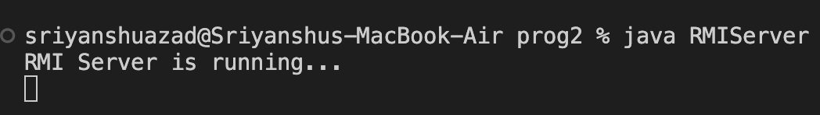

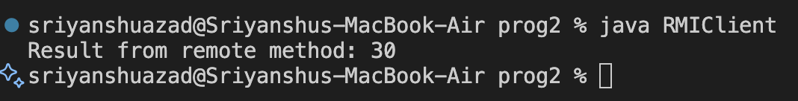

LEARNING OUTCOME:

EXPERIMENT - 3

AIM: Write a java program to implement Lamport’s Logical clock

THEORY:
Lamport’s logical clock is a mechanism proposed by Leslie Lamport (1978) to establish a partial ordering of events in a distributed system where there is no global physical clock.
1. Motivation
In distributed systems:
- Each process has its own local clock.
- There is no global clock to synchronize events.
- Events occur independently and messages take variable time to deliver.
Hence, it becomes difficult to determine the order of events (which happened before which).

2. The “Happens-Before” Relation (→)
Lamport defined a logical ordering relation between events, denoted as “→”:
- If two events a and b occur in the same process and a occurs before b, then
a → b
- If a is the sending of a message and b is the receipt of that same message**, then
a → b
- If a → b and b → c, then a → c (transitive property).
This relation gives a partial order of all events.

3. Logical Clock Rules
Each process Pi maintains a logical clock LCi (an integer counter).
The rules are:
- Increment Rule:
Before each event in process Pi, increment LCi = LCi + 1
- Send Rule:
When a process Pi sends a message m, it attaches its timestamp t = LCi to the message.
- Receive Rule:
When a process Pj receives a message m with timestamp t, it sets
LCj = max(LCj, t) + 1

4. Properties
- If a → b, then LC(a) < LC(b) (causality preserved).
- If LC(a) < LC(b), it does not necessarily mean that a → b (no total order, only partial).

5. Limitations
- Lamport clocks do not capture concurrent events accurately (two events may have the same timestamp even if unrelated).
- They only ensure causal ordering, not total ordering.

6. Applications
- Used in distributed mutual exclusion, event ordering, debugging, and snapshot algorithms.
- Basis for vector clocks, which improve accuracy by capturing concurrency explicitly.

CODE:

import java.util.Scanner;
public class LamportClock {
private int clock;
public LamportClock() {
clock = 0;
}

// internal event
public void event() {
clock++;
System.out.println("Internal event occurred. Clock = " + clock);
}

// send message
public int sendMessage() {
clock++;
System.out.println("Message sent. Clock = " + clock);
return clock;
}

// receive message
public void receiveMessage(int receivedTime) {
clock = Math.max(clock, receivedTime) + 1;
System.out.println("Message received. Updated Clock = " + clock);
}
public static void main(String[] args) {
Scanner sc = new Scanner(System.in);
LamportClock process1 = new LamportClock();
LamportClock process2 = new LamportClock();
System.out.println("Initial clocks -> P1: " + 0 + " P2: " + 0);

System.out.println("\nP1 performs an internal event:");
process1.event();

System.out.println("\nP1 sends a message to P2:");
int msgTime = process1.sendMessage();

System.out.println("\nP2 receives the message:");
process2.receiveMessage(msgTime);

System.out.println("\nP2 performs an internal event:");
process2.event();

System.out.println("\nFinal Clock values:");
System.out.println("P1 clock: " + process1.clock);
System.out.println("P2 clock: " + process2.clock);
}
}

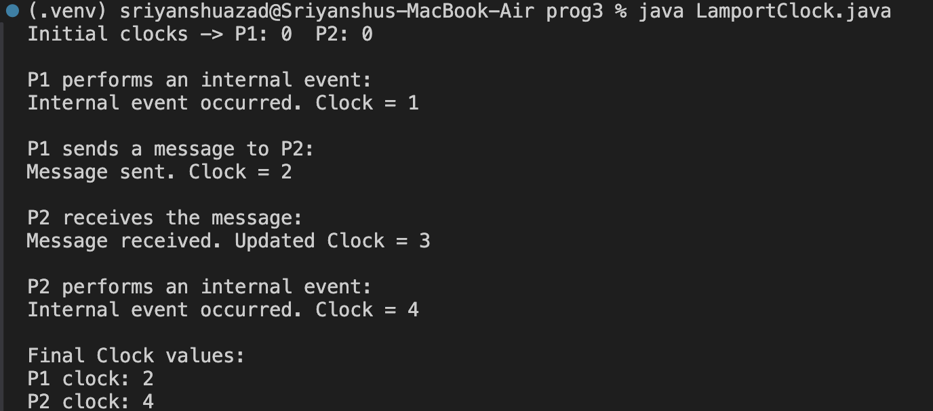
OUTPUT:

LEARNING OUTCOME:

EXPERIMENT - 4

AIM: Implement mutual exclusion service using Lamport’s Mutual Exclusion Algorithm

THEORY:
Lamport’s Mutual Exclusion Algorithm (1978) is a distributed algorithm that ensures mutual exclusion — i.e., only one process enters its critical section (CS) at a time — without using a centralized coordinator or shared memory.

1. Assumptions
- The system has N processes: ( P_1, P_2, ..., P_N ).
- Communication is done via message passing.
- The communication channels are reliable and FIFO-ordered.
- Each process maintains a Lamport Logical Clock (LC).

2. Basic Idea
Each process uses timestamped requests to coordinate access to the critical section (CS).
Requests are ordered by timestamps using Lamport’s logical clocks.

3. Types of Messages
Each process can send or receive the following message types:
- Request (REQ, timestamp, process_id)
- Reply (REP, timestamp, process_id)
- Release (REL, timestamp, process_id)

4. Algorithm Steps
(A) Requesting the Critical Section
When a process ( P_i ) wants to enter its CS:
- It increments its logical clock: ( LC_i = LC_i + 1 )
- Sends a REQUEST message ⟨REQ, LC_i, i⟩ to all other processes (including itself).
- Adds the request to its request queue, ordered by timestamp.
- Waits until:
  - It has received REPLY messages from all other processes, and
  - Its own request is at the head of the queue.
Then ( P_i ) enters the critical section.

(B) Releasing the Critical Section
When ( P_i ) exits the CS:
- It removes its request from the queue.
- Sends a RELEASE message ⟨REL, LC_i, i⟩ to all other processes.

(C) Upon Receiving Messages
- On receiving a REQUEST (REQ, t, j):
  - Add the request to the local request queue.
  - Send a REPLY message back to ( P_j ).
  - Update logical clock: ( LC_i = \max(LC_i, t) + 1 ).
- On receiving a RELEASE (REL, t, j):
  - Remove ( P_j )’s request from the local queue.
  - Update logical clock: ( LC_i = \max(LC_i, t) + 1 ).

5. Properties
Mutual Exclusion: Only one process’s request can be at the head of all queues at a time.
Fairness: Requests are ordered by timestamps — no starvation.
No Deadlock: Every request is eventually served.
Message Complexity:
- Request phase: ( N - 1 ) messages
- Reply phase: ( N - 1 ) messages
- Release phase: ( N - 1 ) messages
→ Total = 3(N − 1) messages per CS entry.

CODE:

import java.util.*;
class LamportProcess implements Comparable<LamportProcess> {
int processId;
int timestamp;

LamportProcess(int processId, int timestamp) {
this.processId = processId;
this.timestamp = timestamp;
}
@Override
public int compareTo(LamportProcess other) {
if (this.timestamp == other.timestamp)
return this.processId - other.processId;
return this.timestamp - other.timestamp;
}
}

public class LamportMutex {
private int clock;
private int processId;
private PriorityQueue<LamportProcess> requestQueue;

public LamportMutex(int processId) {
this.clock = 0;
this.processId = processId;
this.requestQueue = new PriorityQueue<>();
}
// simulate sending a request
public void requestCS() {
clock++;
LamportProcess request = new LamportProcess(processId, clock);
requestQueue.add(request);
System.out.println("Process " + processId + " sends request with timestamp " + clock);
}

// simulate receiving request from another process
public void receiveRequest(int senderId, int senderTime) {
clock = Math.max(clock, senderTime) + 1;
requestQueue.add(new LamportProcess(senderId, senderTime));
System.out
.println("Process " + processId + " received request from P" + senderId + " (time=" + senderTime + ")");
}

// check if this process can enter the critical section
public boolean canEnterCS(int totalProcesses) {
LamportProcess first = requestQueue.peek();
return (first != null && first.processId == processId && requestQueue.size() == totalProcesses);
}

// release critical section
public void releaseCS() {
requestQueue.poll();
clock++;
System.out.println("Process " + processId + " releases critical section (clock=" + clock + ")");
}

public static void main(String[] args) {
int totalProcesses = 3;

LamportMutex p1 = new LamportMutex(1);
LamportMutex p2 = new LamportMutex(2);
LamportMutex p3 = new LamportMutex(3);

System.out.println("=== Lamport Mutual Exclusion Simulation ===\n");

// P1 requests critical section
p1.requestCS();
p2.receiveRequest(1, p1.clock);
p3.receiveRequest(1, p1.clock);

// P2 requests after some time
p2.requestCS();
p1.receiveRequest(2, p2.clock);
p3.receiveRequest(2, p2.clock);

// P3 requests after some time
p3.requestCS();
p1.receiveRequest(3, p3.clock);
p2.receiveRequest(3, p3.clock);

System.out.println("\nChecking who can enter critical section...\n");

if (p1.canEnterCS(totalProcesses)) {
System.out.println("Process 1 enters Critical Section");
p1.releaseCS();
}
if (p2.canEnterCS(totalProcesses)) {
System.out.println("Process 2 enters Critical Section");
p2.releaseCS();
}
if (p3.canEnterCS(totalProcesses)) {
System.out.println("Process 3 enters Critical Section");
p3.releaseCS();
}
}
}

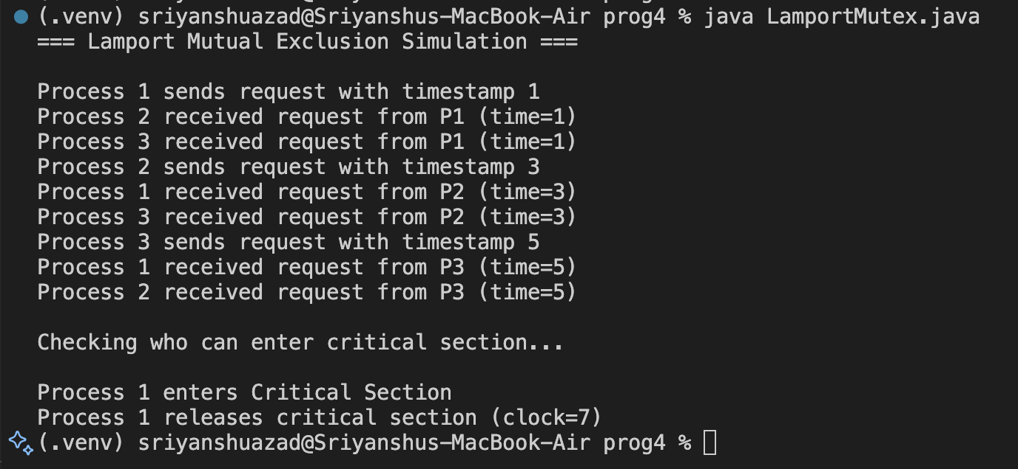
OUTPUT:

LEARNING OUTCOME:

EXPERIMENT - 5

AIM: Install Hadoop on MacOs

THEORY:
Apache Hadoop is an open-source framework developed by the Apache Software Foundation for distributed storage and parallel processing of large datasets across clusters of computers.

1. Introduction
Hadoop allows organizations to store, process, and analyze big data efficiently using a cluster of commodity hardware.
It follows a distributed computing model inspired by Google’s MapReduce and Google File System (GFS).

2. Core Components of Hadoop

Hadoop = HDFS (storage) + MapReduce (processing) + YARN (resource management)

A. Hadoop Distributed File System (HDFS)
- A distributed storage system designed for high throughput and fault tolerance.
- Data is split into blocks (default 128 MB or 256 MB) and replicated (default 3 copies) across different nodes.
- Components:
  - NameNode: Master server that manages metadata (directory structure, block locations).
  - DataNode: Worker nodes that store actual data blocks and send heartbeat signals to NameNode.
B. MapReduce
- A programming model for distributed computation.
- Processes data in two main phases:
  - Map Phase: Processes input data and produces intermediate key-value pairs.
  - Reduce Phase: Aggregates the results based on keys to produce the final output.

C. YARN (Yet Another Resource Negotiator)
- The resource management layer of Hadoop (introduced in Hadoop 2.x).
- Components:
  - ResourceManager (RM): Allocates resources to applications.
  - NodeManager (NM): Manages containers on individual nodes.
  - ApplicationMaster (AM): Coordinates tasks of a single job.

D. Hadoop Common
- A set of Java libraries and utilities required by other Hadoop modules.
- Provides file system, serialization, and RPC (Remote Procedure Call) functionalities.

3. Features
- Scalable: Can easily scale from a few nodes to thousands.
- Fault-tolerant: Data replication ensures reliability even if a node fails.
- Cost-effective: Works on commodity hardware.
- High throughput: Designed for batch processing of massive data.

PROCEDURE:

- Install Java (JDK8 or later)
brew install openjdk@17

2. Download Hadoop
brew install Hadoop

3. Configure Environment Variables
1. Edit your shell config (~/.zshrc or ~/.bashrc):

nano ~/.zshrc

2. Add these lines
# Hadoop (Homebrew install)
export HADOOP_HOME=/opt/homebrew/Cellar/hadoop/3.3.6
export HADOOP_COMMON_HOME=$HADOOP_HOME
export HADOOP_HDFS_HOME=$HADOOP_HOME
export HADOOP_MAPRED_HOME=$HADOOP_HOME
export HADOOP_YARN_HOME=$HADOOP_HOME
export HADOOP_CONF_DIR=$HADOOP_HOME/libexec/etc/hadoop
export PATH=$PATH:$HADOOP_HOME/bin:$HADOOP_HOME/sbin
export JAVA_HOME=$(/usr/libexec/java_home)

3. Apply the changes
source ~/.zshrc

4. Check Hadoop Version

hadoop -version
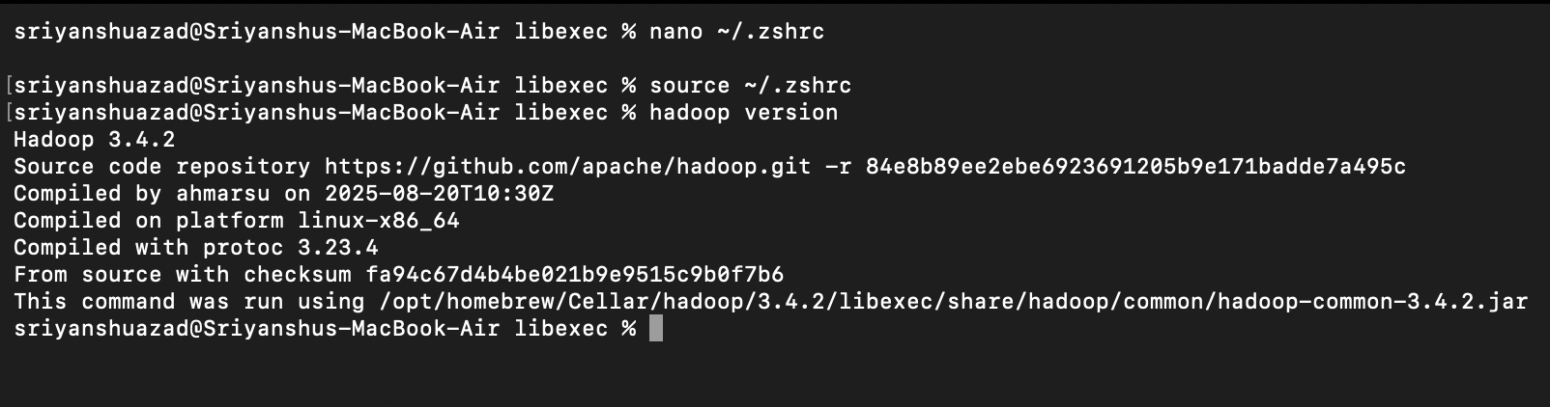

4. Configure Hadoop

Go to Hadoop config directory:
cd $HADOOP_HOME/etc/hadoop

(a) Edit hadoop-env.sh

nano hadoop-env.sh

Find and set:
export JAVA_HOME=$(/usr/libexec/java_home)

(b) Edit core-site.xml
Add inside <configuration>:
<property>
<name>fs.defaultFS</name>
<value>hdfs://localhost:9000</value>
</property>

(c) Edit hdfs-site.xml

<property>
<name>dfs.replication</name>
<value>1</value>
</property>
<property>
<name>dfs.namenode.name.dir</name>
<value>file:///usr/local/hadoop_tmp/hdfs/namenode</value>
</property>
<property>
<name>dfs.datanode.data.dir</name>
<value>file:///usr/local/hadoop_tmp/hdfs/datanode</value>
</property>

(d) Edit mapred-site.xml
If file doesn’t exist:
cp mapred-site.xml.template mapred-site.xml
Then:

<configuration>
<property>
<name>mapreduce.framework.name</name>
<value>yarn</value>
</property>

<property>
<name>yarn.app.mapreduce.am.env</name>
<value>HADOOP_MAPRED_HOME=${HADOOP_HOME}</value>
</property>

<property>
<name>mapreduce.map.env</name>
<value>HADOOP_MAPRED_HOME=${HADOOP_HOME}</value>
</property>

<property>
<name>mapreduce.reduce.env</name>
<value>HADOOP_MAPRED_HOME=${HADOOP_HOME}</value>
</property>
</configuration>

(e) Edit yarn-site.xml

<property>
<name>yarn.nodemanager.aux-services</name>
<value>mapreduce_shuffle</value>
</property>

5. Format the Namenode

hdfs namenode -format

6. Start Hadoop Daemons

start-dfs.sh
start-yarn.sh

Check if they’re running:
jps

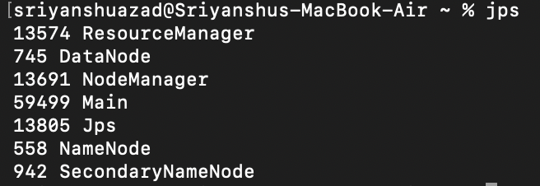

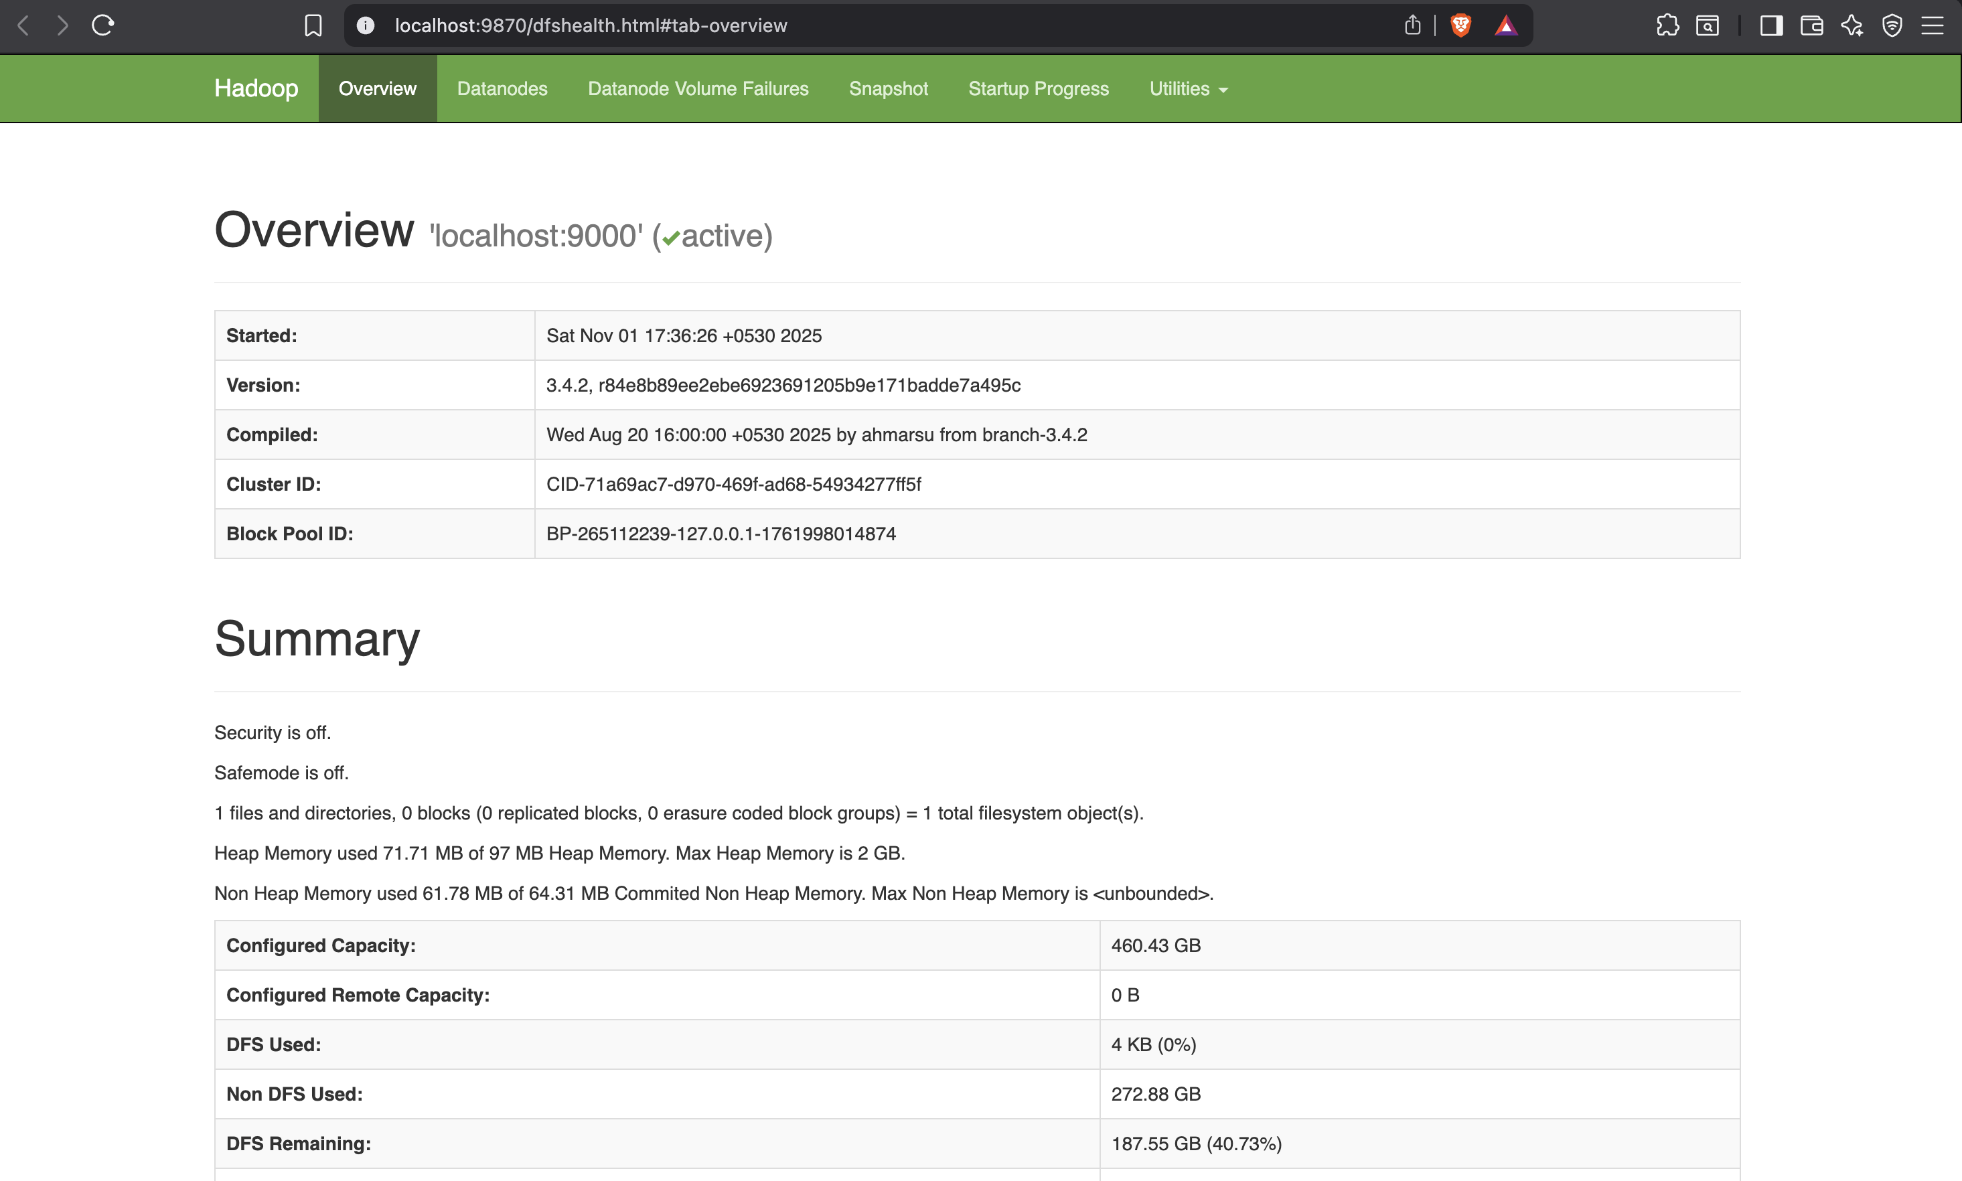
7. Access Hadoop Web UIs
- NameNode UI → http://localhost:9870
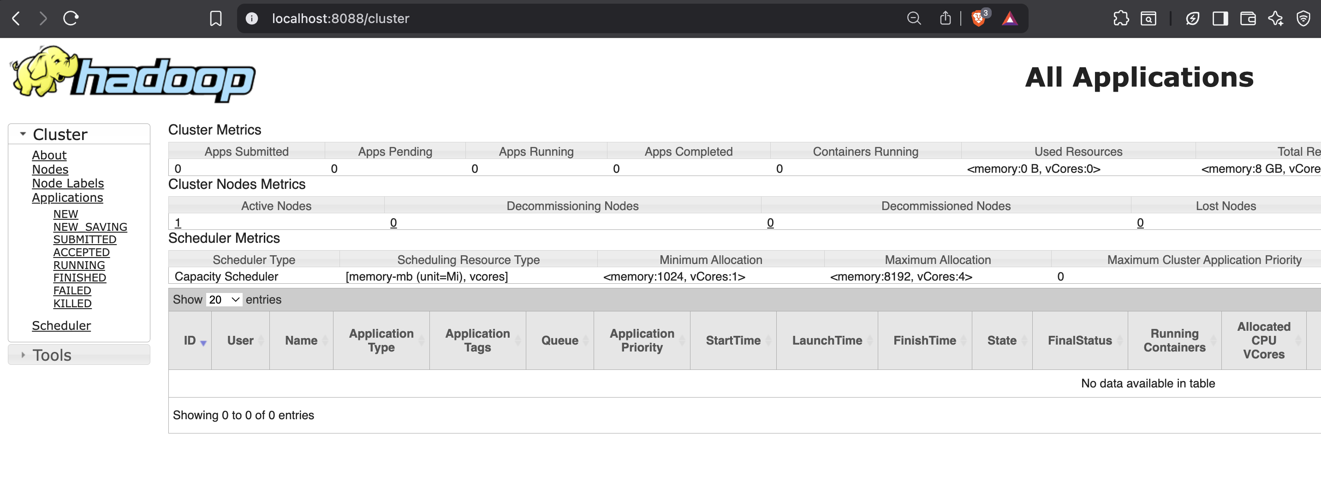
- ResourceManager UI → http://localhost:8088
8. Stop Hadoop

stop-dfs.sh
stop-yarn.sh

Learning Outcomes:

EXPERIMENT - 6

AIM: Run a simple application on single node Hadoop Cluster.

THEORY:

A Single-Node Hadoop Cluster (also called pseudo-distributed mode) is a configuration of Hadoop where all the daemons (NameNode, DataNode, ResourceManager, NodeManager, etc.) run on a single machine instead of multiple nodes.
It is mainly used for learning, development, and testing, not for production.
Component | Role
NameNode | Manages file system metadata (directory, blocks).
DataNode | Stores actual data blocks.
ResourceManager | Allocates cluster resources for jobs.
NodeManager | Manages containers on the local node.
Secondary NameNode | Periodically merges namespace and edit logs.

A Hadoop cluster generally has:
- Master nodes – run NameNode, ResourceManager, etc.
- Slave nodes – run DataNode, NodeManager, etc.
In a single-node cluster, both master and slave processes run on the same system.

Modes of Hadoop Operation
Mode | Description | Use
Local (Standalone) | No HDFS; runs on local filesystem | Testing small programs
Pseudo-Distributed (Single Node) | All daemons run on one machine using HDFS | Learning, development
Fully Distributed (Multi-node) | Daemons run on multiple machines | Production setup

Daemons Running in a Single-Node Cluster

All of these run on one machine.

CODE:

import java.io.IOException;
import java.util.StringTokenizer;
import org.apache.hadoop.conf.Configuration;
import org.apache.hadoop.fs.Path;
import org.apache.hadoop.io.IntWritable;
import org.apache.hadoop.io.Text;
import org.apache.hadoop.mapreduce.Job;
import org.apache.hadoop.mapreduce.Mapper;
import org.apache.hadoop.mapreduce.Reducer;
import org.apache.hadoop.mapreduce.lib.input.FileInputFormat;
import org.apache.hadoop.mapreduce.lib.output.FileOutputFormat;

public class WordCount {

public static class TokenizerMapper
extends Mapper<Object, Text, Text, IntWritable>{

private final static IntWritable one = new IntWritable(1);
private Text word = new Text();

public void map(Object key, Text value, Context context
) throws IOException, InterruptedException {
StringTokenizer itr = new StringTokenizer(value.toString());
while (itr.hasMoreTokens()) {
word.set(itr.nextToken());
context.write(word, one);
}
}
}

public static class IntSumReducer
extends Reducer<Text,IntWritable,Text,IntWritable> {
private IntWritable result = new IntWritable();

public void reduce(Text key, Iterable<IntWritable> values,
Context context
) throws IOException, InterruptedException {
int sum = 0;
for (IntWritable val : values) {
sum += val.get();
}
result.set(sum);
context.write(key, result);
}
}

public static void main(String[] args) throws Exception {
Configuration conf = new Configuration();
Job job = Job.getInstance(conf, "word count");
job.setJarByClass(WordCount.class);
job.setMapperClass(TokenizerMapper.class);
job.setCombinerClass(IntSumReducer.class);
job.setReducerClass(IntSumReducer.class);
job.setOutputKeyClass(Text.class);
job.setOutputValueClass(IntWritable.class);
FileInputFormat.addInputPath(job, new Path(args[0]));
FileOutputFormat.setOutputPath(job, new Path(args[1]));
System.exit(job.waitForCompletion(true) ? 0 : 1);
}
}

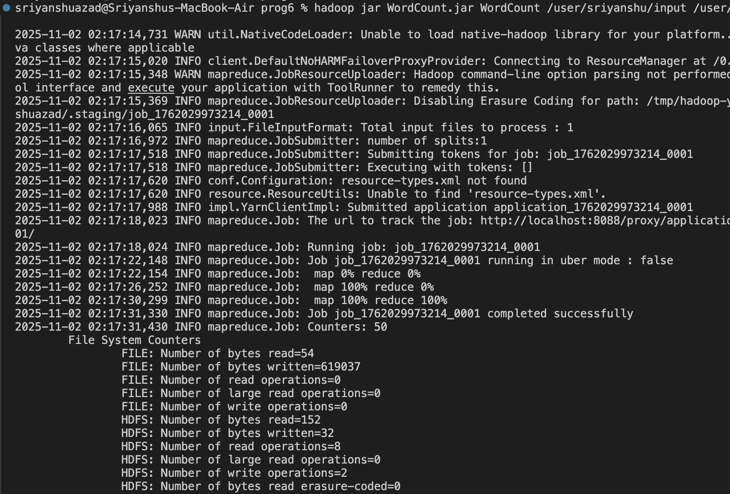
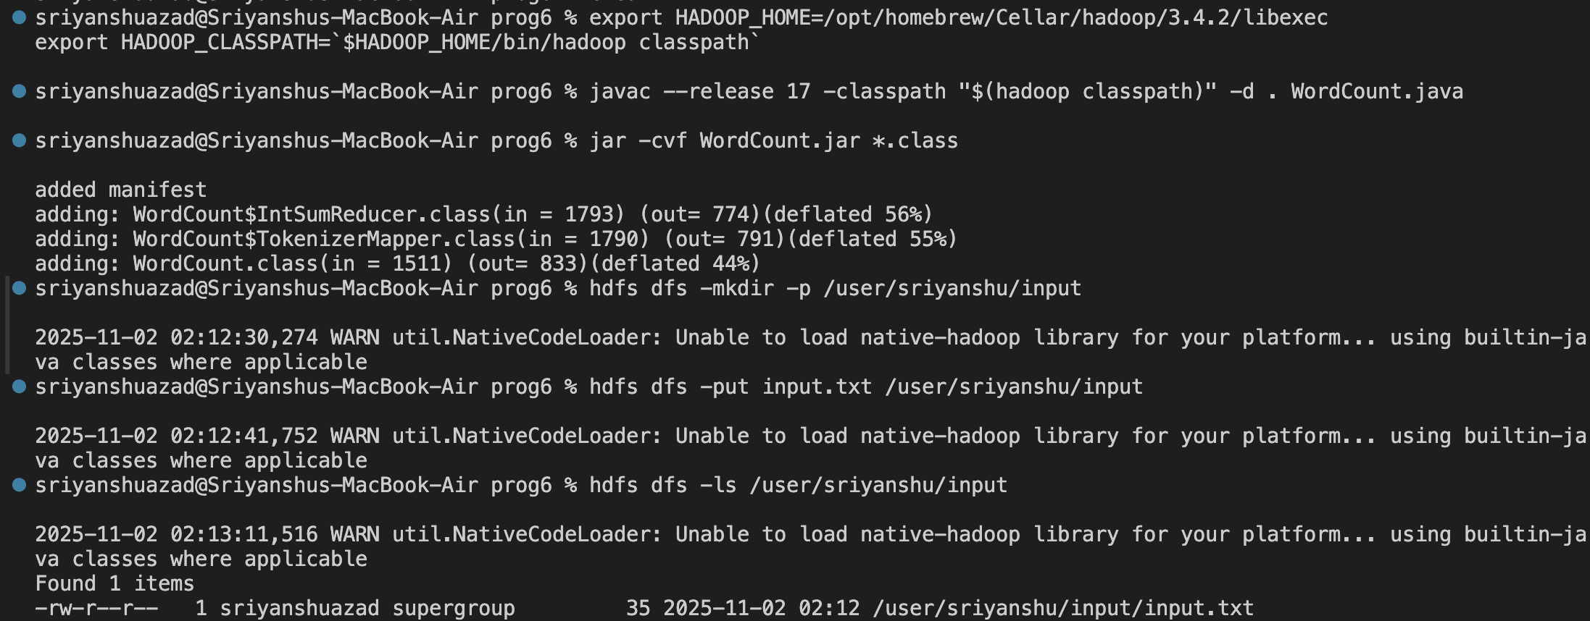
OUTPUT:
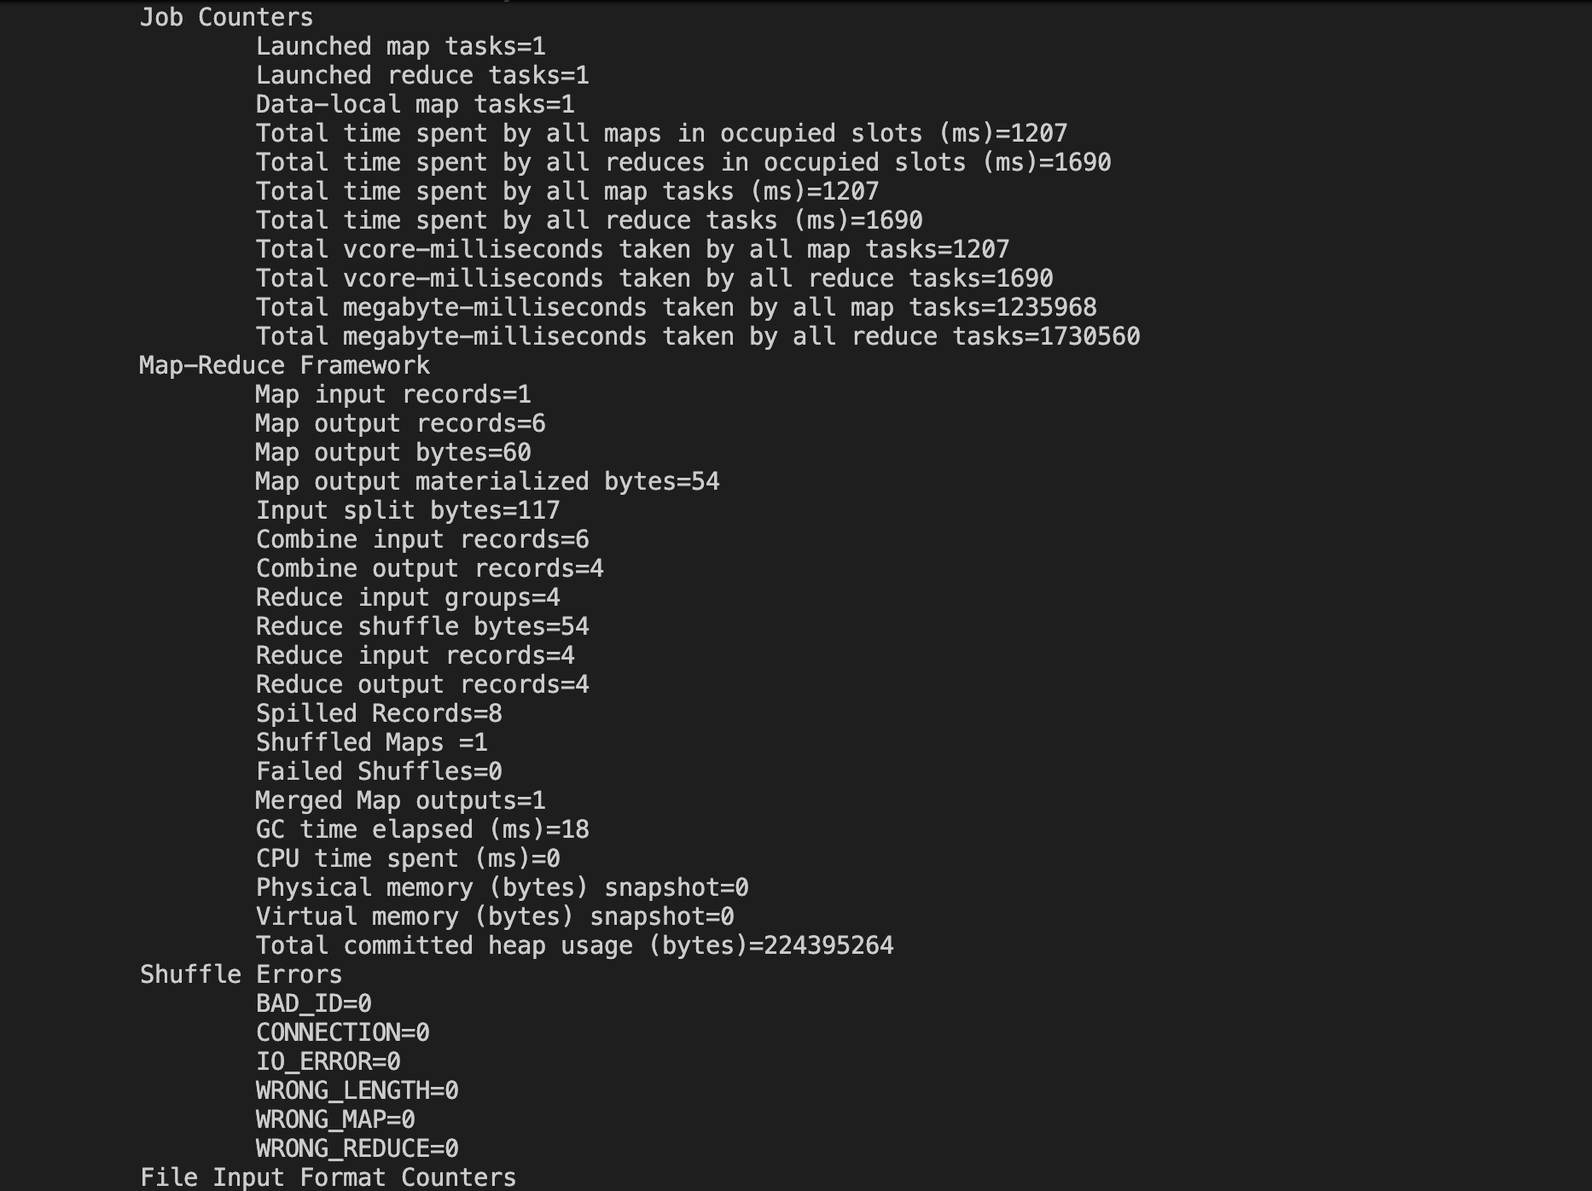
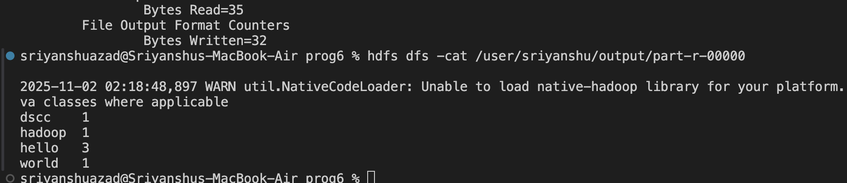
LEARNING OUTCOME:

EXPERIMENT - 7

AIM: Install Google App Engine/AWS/Render and develop a simple web application.

THEORY:

Cloud computing is a technology that allows users to access computing resources (like servers, storage, databases, software, and networking) over the internet on a pay-as-you-use basis.
Instead of buying and maintaining physical servers or data centers, individuals and organizations can rent computing power and storage from cloud service providers.
Examples:
Amazon Web Services (AWS), Microsoft Azure, Google Cloud Platform (GCP), IBM Cloud, Render.

Characteristics of Cloud Computing
- On-Demand Self-Service:
Users can provision computing resources automatically, without human intervention.
- Broad Network Access:
Services are available over the Internet and accessible via devices like laptops, mobiles, etc.
- Resource Pooling:
Resources (servers, storage, etc.) are shared among multiple users through multi-tenancy.
- Rapid Elasticity:
Resources can be scaled up or down quickly based on demand.
- Measured Service:
Users pay only for what they use (utility model).

CODE:

#app.py

from flask import Flask

app = Flask(__name__)

@app.route('/')
def home():
return "Hello, from Render Cloud Deployment!"

if __name__ == '__main__':
app.run(host='0.0.0.0', port=5000)
#requirements.txt
flask
gunicorn

#Procfile
web: gunicorn app:app

#Make a repository on GitHub
git init
git add .
git commit -m "Render test app"
git branch -M main
git remote add origin https://github.com/sriiyanshu/CloudLab.git
git push -u origin main

On Render Website
- Login
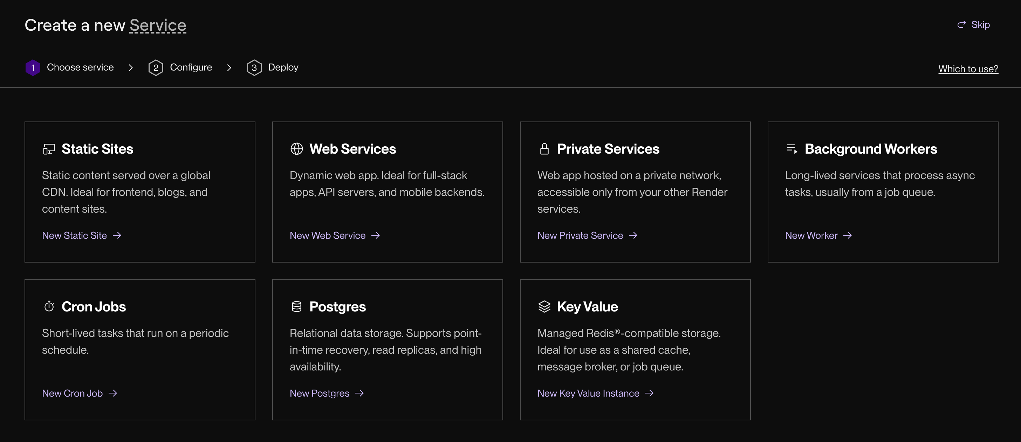
- Select Web Services

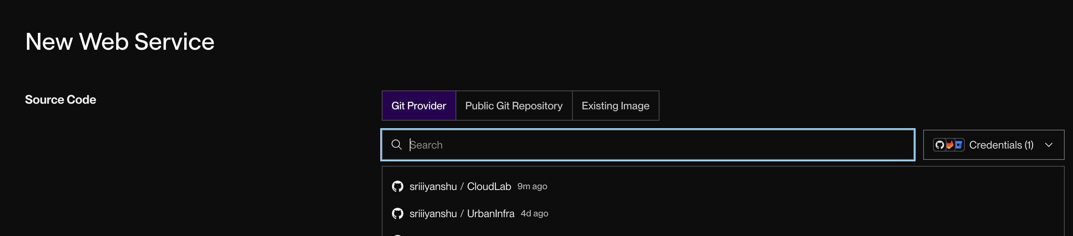
3. Select Github repo

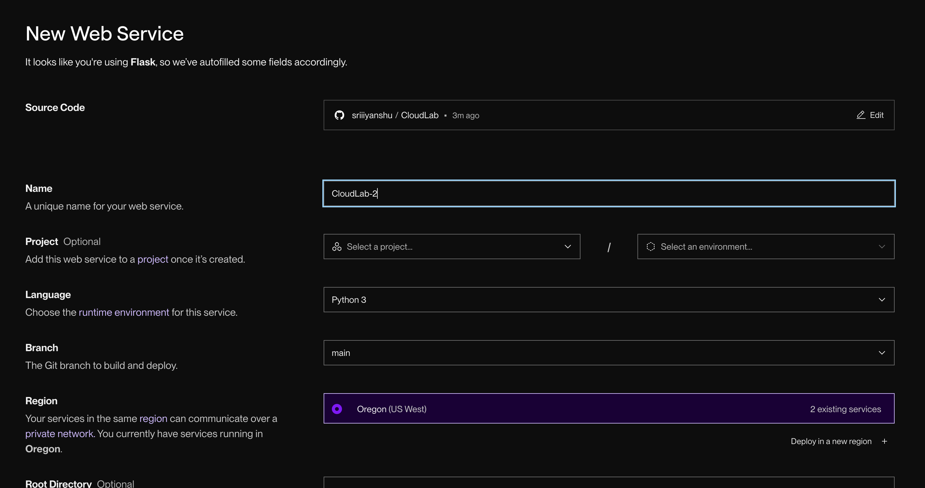
4. Configure the settings, environment, deployment plan.

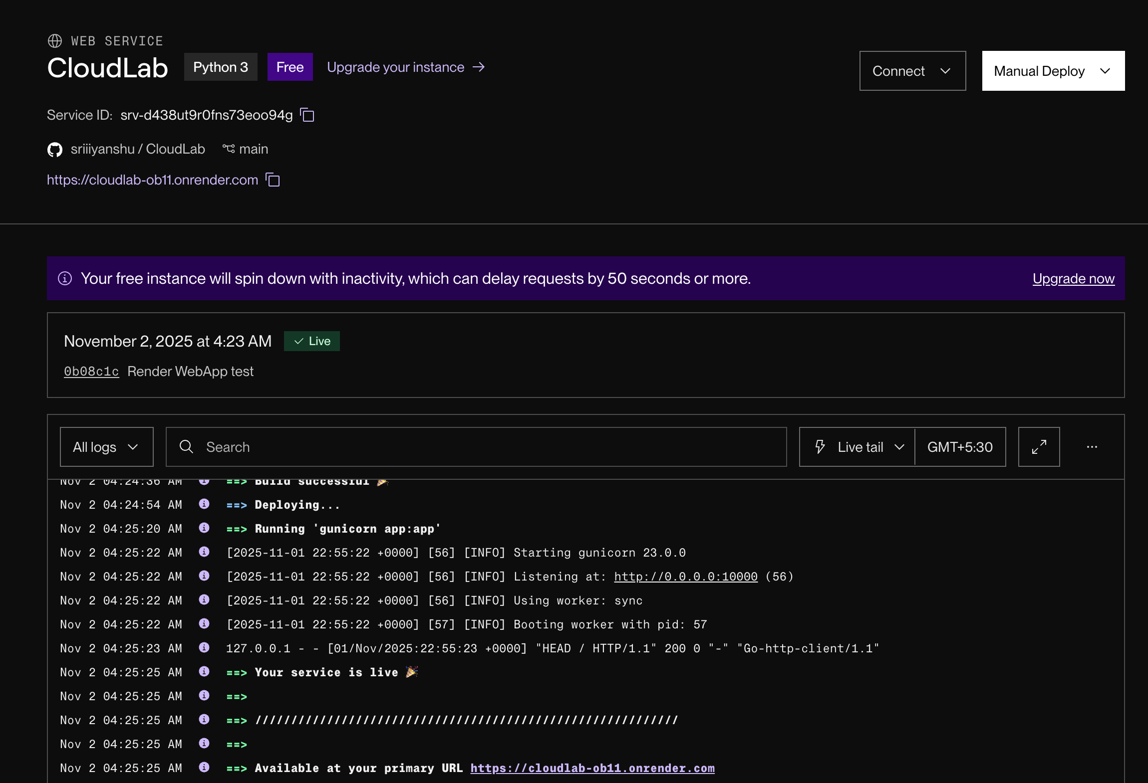
5. Wait for Build and Deployment

OUTPUT:

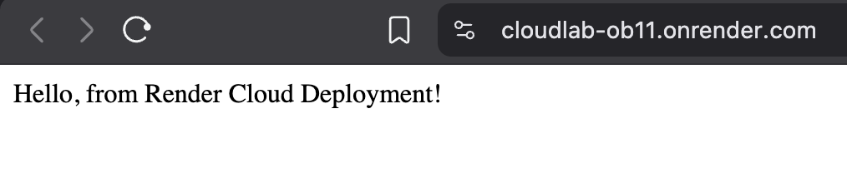
Live at: https://cloudlab-ob11.onrender.com
LEARNING OUTCOME:

EXPERIMENT - 8

AIM: Launch Web application using Google App Engine/ AWS/ Render.

THEORY:

Web app deployment on cloud means hosting a web application (frontend + backend + database) on a cloud platform so that users can access it via the Internet.
Instead of maintaining physical servers, developers use cloud-based infrastructure to deploy, run, and scale their applications efficiently.

Need for Cloud Deployment
- Traditional hosting is limited in scalability and reliability.
- Cloud platforms offer automatic scaling, global access, security, and pay-as-you-use pricing.
- It allows developers to focus on building applications, not managing hardware.

Steps in Cloud Deployment
- Develop the Web Application
  - Built using technologies like HTML/CSS/JS (frontend) and Flask, Django, Node.js, or Java (backend).
  - Connects to a database (MySQL, MongoDB, PostgreSQL, etc.).
- Choose a Cloud Platform
  - Examples: AWS, Azure, Google Cloud, Vercel, Render, DigitalOcean, or Heroku.
  - Selection depends on app type, cost, scalability, and language support.
- Provision Cloud Resources
  - Create a virtual machine (VM) or use Platform-as-a-Service (PaaS) for easy setup.
  - Configure CPU, RAM, and storage.
- Deploy Application Code
  - Upload code via Git, FTP, or CLI tools.
  - Some platforms (like Vercel or Render) deploy automatically from GitHub.
- Set Up Web Server
  - Use servers like Apache, Nginx, or Gunicorn to handle client requests.
- Configure Domain and SSL
  - Map your custom domain to the cloud IP.
  - Enable HTTPS using SSL certificates for secure communication.
- Database and Storage Integration
  - Use cloud databases (e.g., AWS RDS, Azure SQL, Firebase) or cloud storage (e.g., AWS S3).

- Monitor and Scale
  - Use monitoring tools (e.g., CloudWatch, Azure Monitor) for performance and uptime.
  - Enable auto-scaling to handle variable traffic.

CODE:

sum-app/
├── app.py
├── requirements.txt
├── Procfile
└── templates/
└── index.html

app.py

from flask import Flask, render_template, request

app = Flask(__name__)

@app.route('/')
def home():
return render_template('index.html')

@app.route('/calculate', methods=['POST'])
def calculate():
try:
num1 = float(request.form['num1'])
num2 = float(request.form['num2'])
total = num1 + num2
return render_template('index.html', result=total, num1=num1, num2=num2)
except ValueError:
return render_template('index.html', error="Please enter valid numbers")

if __name__ == '__main__':
app.run(host='0.0.0.0', port=5000)

index.html
<!DOCTYPE html>
<html lang="en">
<head>
<meta charset="UTF-8" />
<meta name="viewport" content="width=device-width, initial-scale=1.0" />
<title>Sum Calculator</title>
<style>
body {
font-family: Arial, sans-serif;
background: #f5f7fa;
display: flex;
flex-direction: column;
align-items: center;
justify-content: center;
height: 100vh;
}
.card {
background: white;
padding: 2rem;
border-radius: 10px;
box-shadow: 0 4px 8px rgba(0, 0, 0, 0.1);
text-align: center;
}
input {
width: 80px;
padding: 0.5rem;
margin: 0.5rem;
text-align: center;
}
button {
background: #007bff;
color: white;
border: none;
padding: 0.5rem 1rem;
border-radius: 5px;
cursor: pointer;
}
button:hover {
background: #0056b3;
}
.result {
margin-top: 1rem;
font-size: 1.2rem;
color: green;
}
.error {
color: red;
margin-top: 1rem;
}
</style>
</head>
<body>
<div class="card">
<h2>Sum Calculator</h2>
<form method="POST" action="/calculate">
<input type="text" name="num1" placeholder="Number 1" required value="{{ num1 or '' }}" />
<input type="text" name="num2" placeholder="Number 2" required value="{{ num2 or '' }}" />
<br />
<button type="submit">Calculate</button>
</form>

{% if result is defined %}
<div class="result">Sum = {{ result }}</div>
{% endif %} {% if error %}
<div class="error">{{ error }}</div>
{% endif %}
</div>
</body>
</html>

requirements.txt
flask
gunicorn

Procfile
web: gunicorn app:app

OUTPUT:

Live at: https://cloudlab-1-9yud.onrender.com
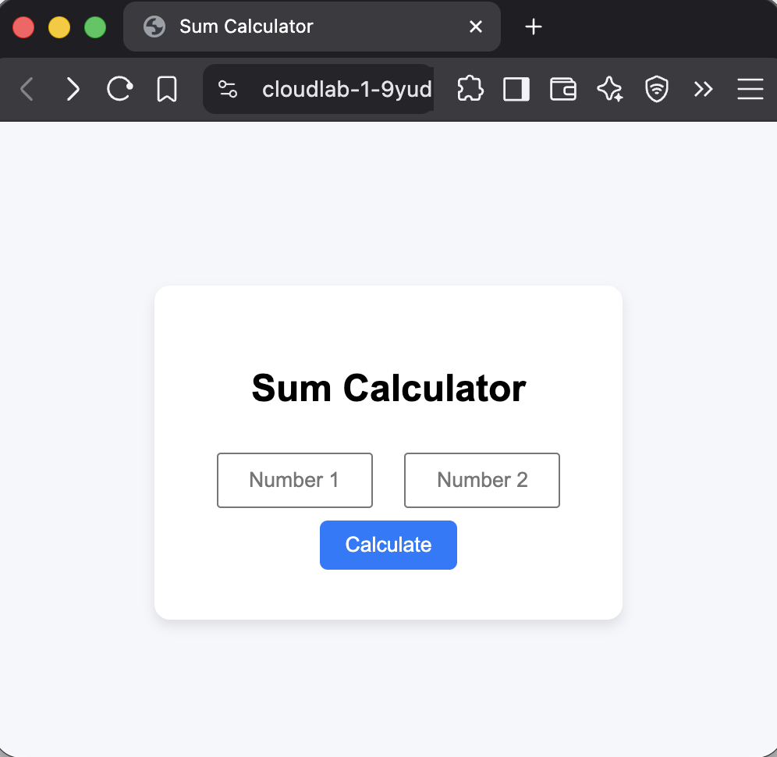
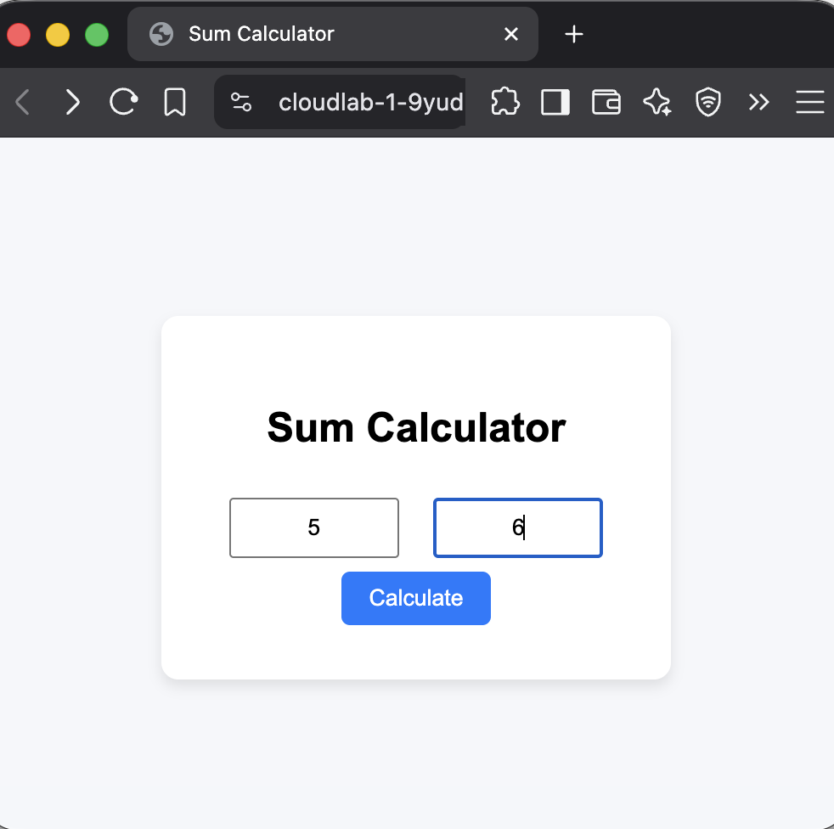

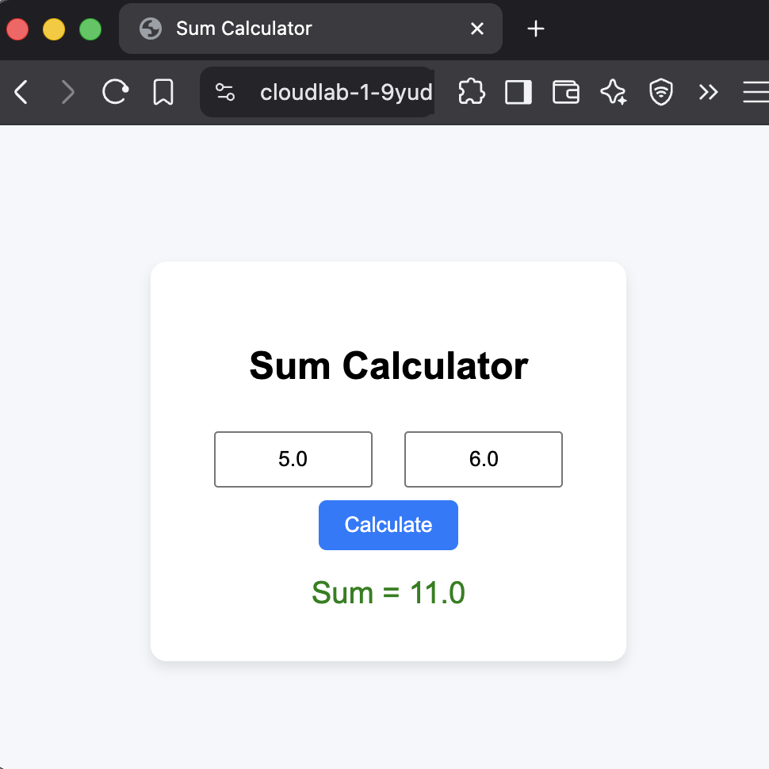

LEARNING OUTCOME:

EXPERIMENT - 9

AIM: Install Virtualbox / VMware with different flavours of linux on windows/Mac.

THEORY:

A Virtual Machine (VM) is a software-based emulation of a physical computer that runs an operating system (OS) and applications just like a real machine.
It is created using a hypervisor that divides the physical machine’s resources—CPU, memory, storage—into multiple isolated virtual environments.

How Virtual Machines Work
- The hypervisor abstracts the underlying hardware.
- It allocates CPU, RAM, and disk space to each VM.
- Each VM runs its own operating system independently of others.
- The host system can run multiple VMs simultaneously.

Applications
- Cloud Computing: VMs form the base of cloud services like AWS EC2 or Azure VMs.
- Software Testing: Run multiple OS environments on one computer.
- Server Consolidation: Run several servers virtually on a single physical system.
- Education & Training: Learn OS installation and networking safely.
Types of Hypervisors - The software layer that manages and allocates resources to VMs.
Type | Description | Examples
Type 1 (Bare-metal) | Runs directly on hardware, offering better performance and security. | VMware ESXi, Microsoft Hyper-V, Xen
Type 2 (Hosted) | Runs on top of a host OS, easier to set up for personal use. | VirtualBox, VMware Workstation

PROCEDURE:

1. Install VMWare and add linux .iso file
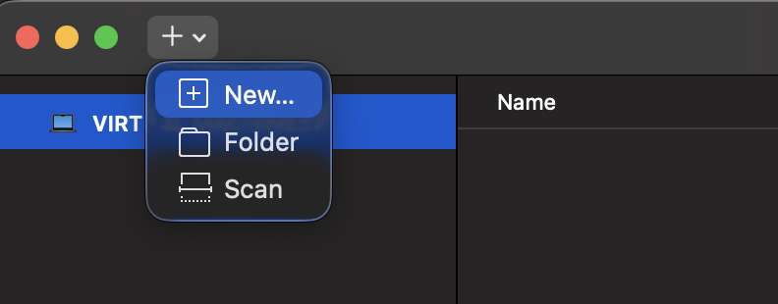

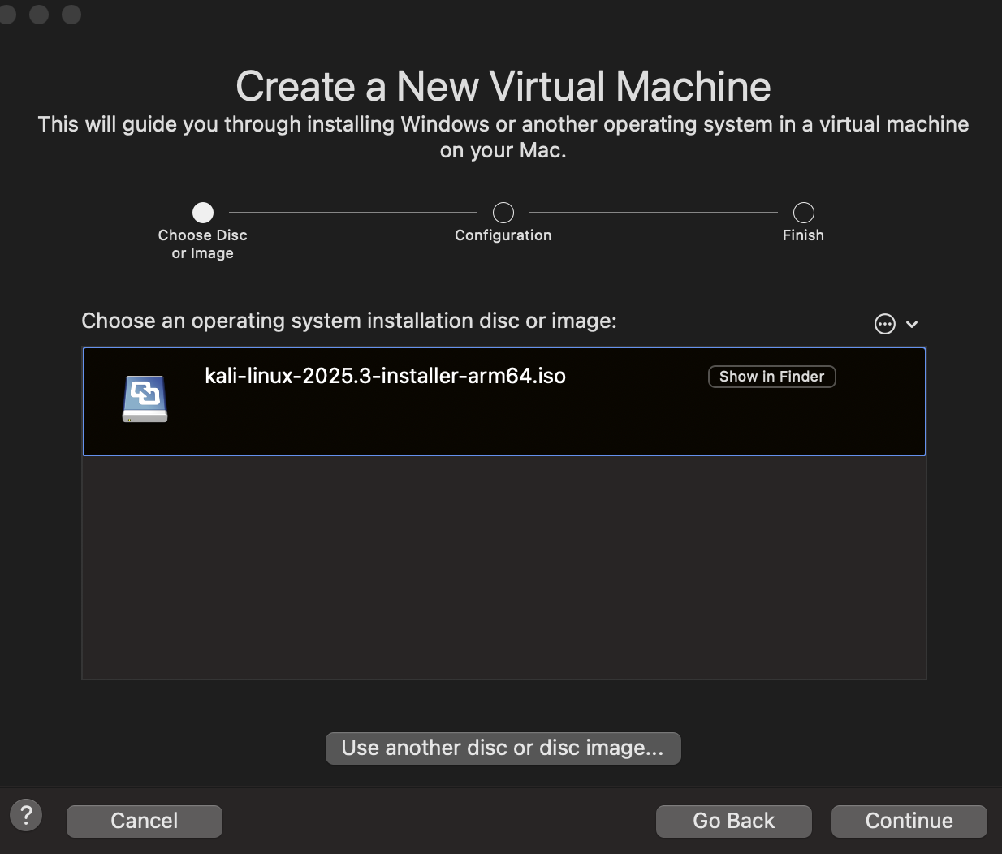

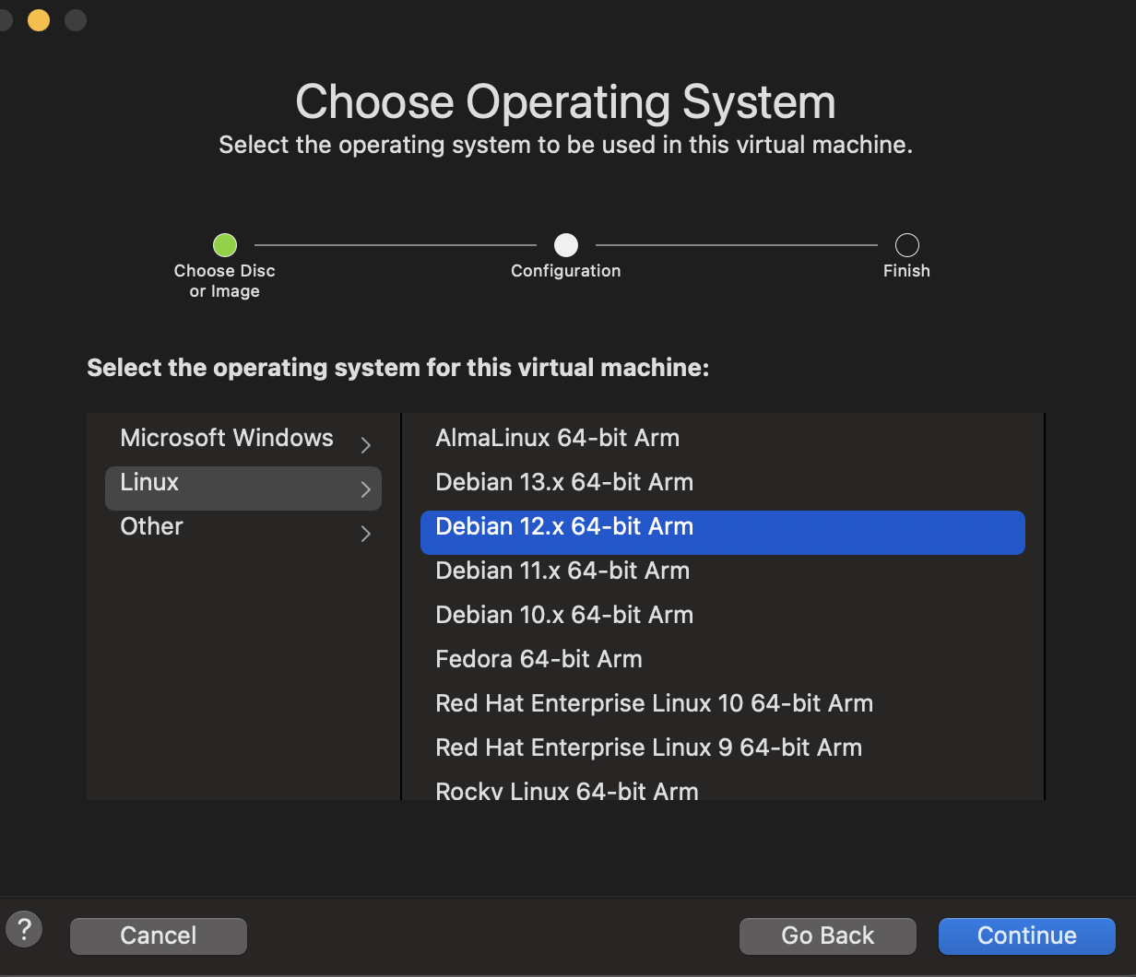
2. Set up OS and resources for linux.
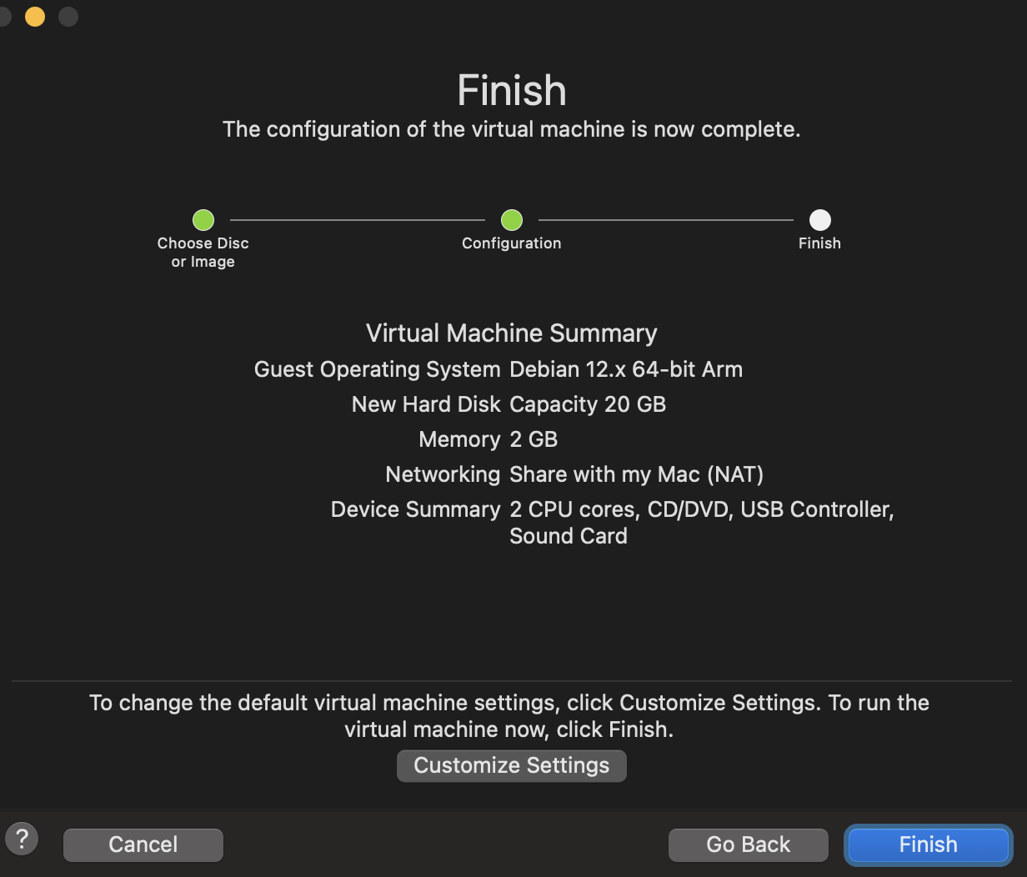

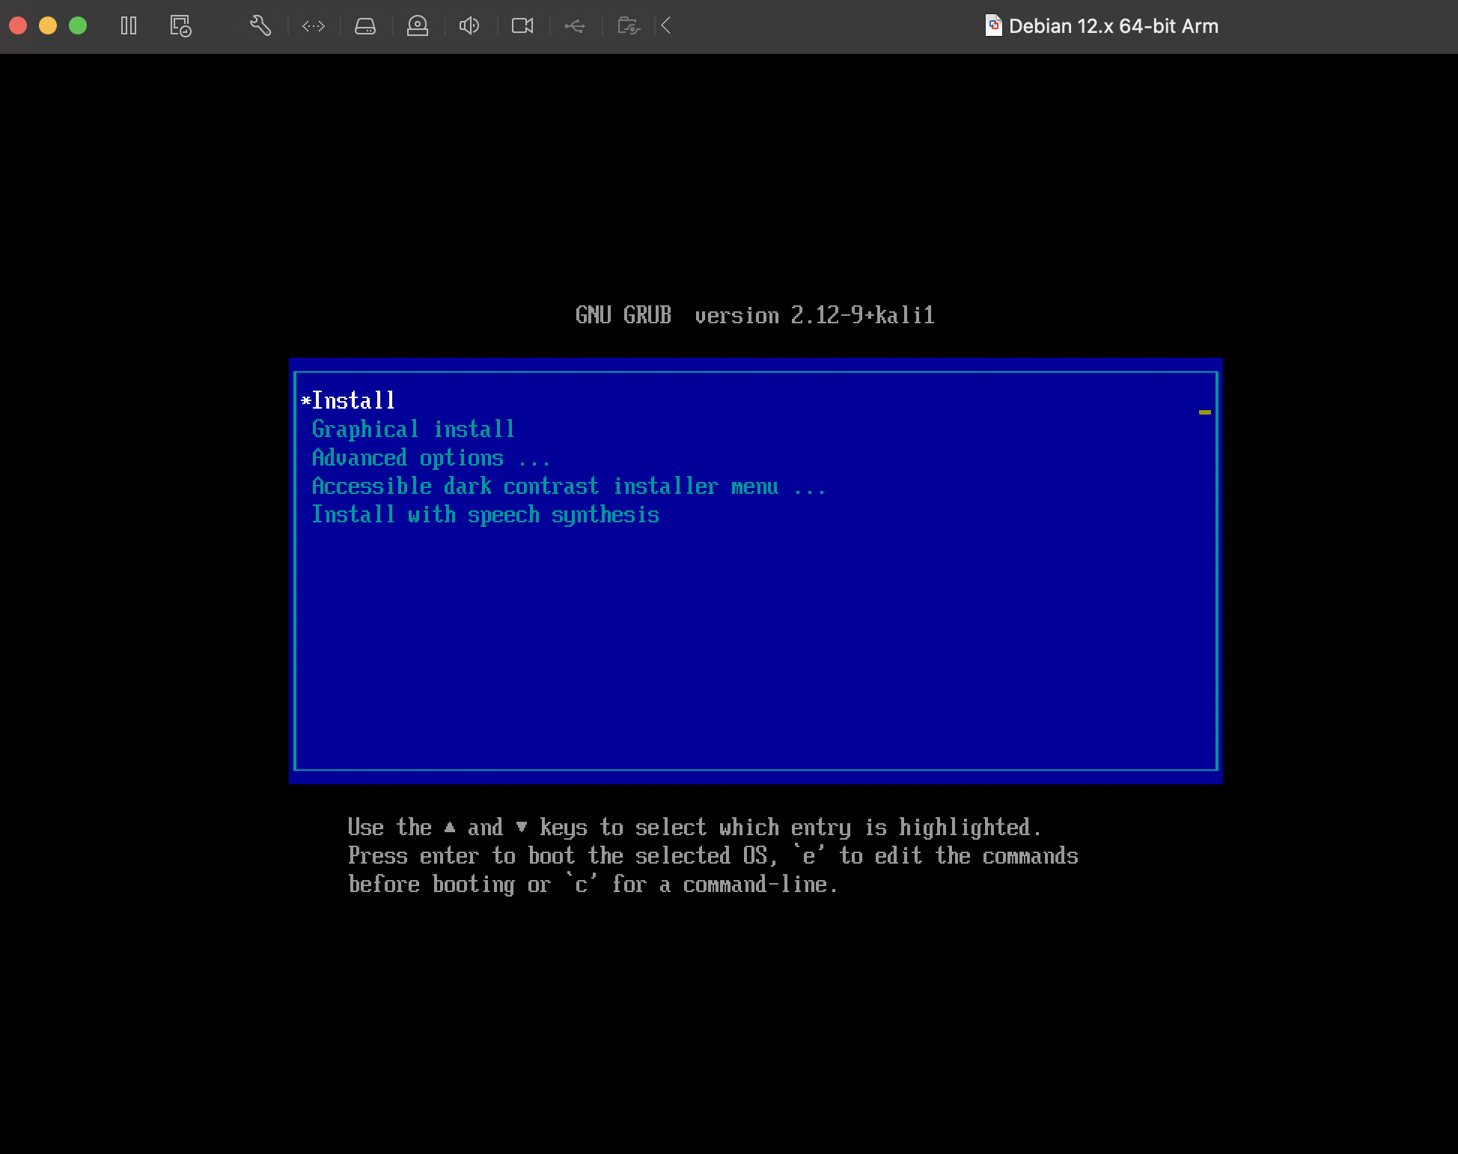
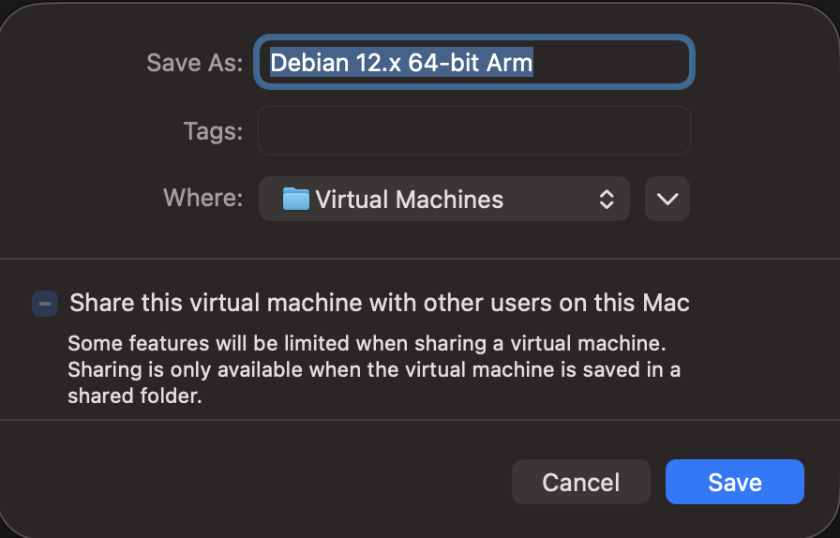
3. Install Linux (here Kali)
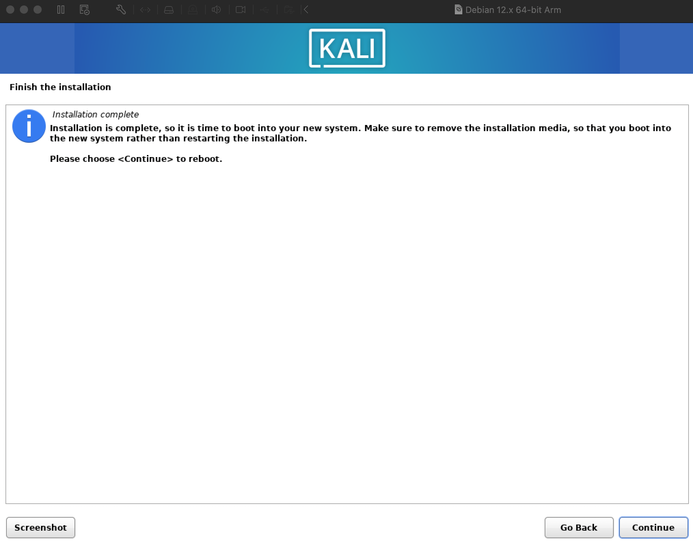
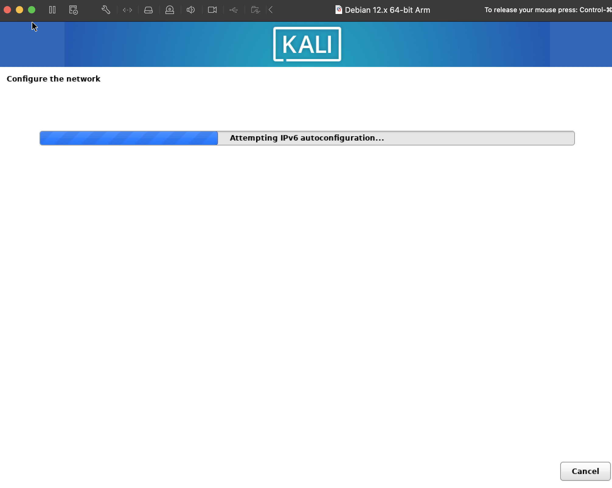


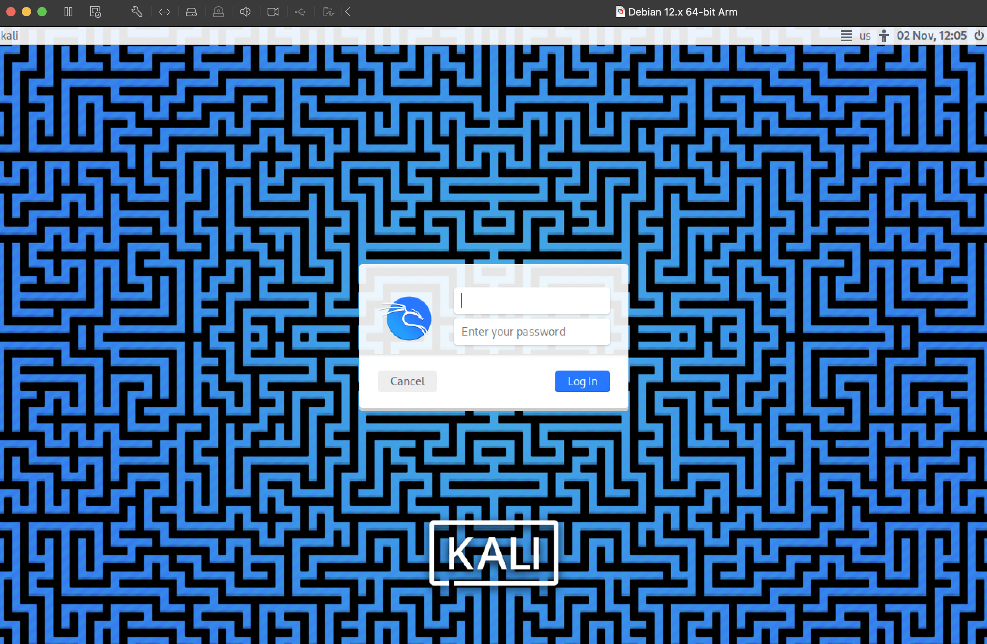
4. Login to finish setup.

LEARNING OUTCOME:

EXPERIMENT - 10

AIM: Simulate a cloud scenario using CloudSim and run a scheduling algorithm

THEORY:

CloudSim is an open-source, Java-based event-driven simulation toolkit for modelling and experimenting with cloud computing infrastructures (data centers, hosts, VMs, scheduling, allocation policies, network- and power-aware scenarios). It lets researchers evaluate resource provisioning, scheduling and trade-offs without running real cloud hardware. GitHub+1
Why use CloudSim
- Reproducible experiments on large-scale scenarios without cost. cloudsimtutorials.online
- Extensible: you can implement custom VmAllocationPolicy, DatacenterBroker, scheduling policies, and new modules (containers, power models, etc.). clouds.cis.unimelb.edu.au+1
- Widely used in academic research (newer “7G” refactoring improves performance & APIs).

CODE:

package org.cloudbus.cloudsim.examples;

import java.text.DecimalFormat;
import java.util.*;
import org.cloudbus.cloudsim.*;
import org.cloudbus.cloudsim.core.CloudSim;
import org.cloudbus.cloudsim.provisioners.BwProvisionerSimple;
import org.cloudbus.cloudsim.provisioners.PeProvisionerSimple;
import org.cloudbus.cloudsim.provisioners.RamProvisionerSimple;

public class CloudSimDemo {

public static void main(String[] args) {
// Step 1: Initialize the CloudSim library
int numUsers = 1;
Calendar calendar = Calendar.getInstance();
boolean traceFlag = false;
CloudSim.init(numUsers, calendar, traceFlag);

// Step 2: Create Datacenter
Datacenter datacenter = createDatacenter("Datacenter_1");

// Step 3: Create Broker
DatacenterBroker broker;
try {
broker = new DatacenterBroker("Broker");
} catch (Exception e) {
throw new RuntimeException(e);
}
int brokerId = broker.getId();

// Step 4: Create VMs
List<Vm> vmList = new ArrayList<>();
int vmid = 0;
int mips = 1000;
long size = 10000; // image size (MB)
int ram = 512; // VM memory (MB)
long bw = 1000;
int pesNumber = 1; // number of CPU cores
String vmm = "Xen"; // VMM name

for (int i = 0; i < 2; i++) {
Vm vm = new Vm(vmid++, brokerId, mips, pesNumber, ram, bw, size, vmm,
new CloudletSchedulerTimeShared());
vmList.add(vm);
}

// submit VMs to the broker (CloudSim 7 uses submitGuestList)
broker.submitGuestList(vmList);

// Step 5: Create Cloudlets (tasks)
List<Cloudlet> cloudletList = new ArrayList<>();
int id = 0;
long length = 40000;
long fileSize = 300;
long outputSize = 300;
UtilizationModel utilizationModel = new UtilizationModelFull();

for (int i = 0; i < 4; i++) {
Cloudlet cloudlet = new Cloudlet(id++, length, pesNumber, fileSize, outputSize,
utilizationModel, utilizationModel, utilizationModel);
cloudlet.setUserId(brokerId);
// Bind cloudlet to a VM (round-robin)
cloudlet.setGuestId(vmList.get(i % vmList.size()).getId());
cloudletList.add(cloudlet);
}

broker.submitCloudletList(cloudletList);

// Step 6: Start Simulation
CloudSim.startSimulation();

// Step 7: Stop Simulation
CloudSim.stopSimulation();

// Step 8: Print Results
List<Cloudlet> resultList = broker.getCloudletReceivedList();
printCloudletList(resultList);

System.out.println("Simulation completed successfully!");
}

private static Datacenter createDatacenter(String name) {
List<Host> hostList = new ArrayList<>();

// Create 2 hosts with 2 CPUs each
for (int i = 0; i < 2; i++) {
List<Pe> peList = new ArrayList<>();
peList.add(new Pe(0, new PeProvisionerSimple(1000)));
peList.add(new Pe(1, new PeProvisionerSimple(1000)));

int hostId = i;
int ram = 2048;
long storage = 1000000;
int bw = 10000;

hostList.add(new Host(
hostId,
new RamProvisionerSimple(ram),
new BwProvisionerSimple(bw),
storage,
peList,
new VmSchedulerTimeShared(peList)
));
}

String arch = "x86"; // system architecture
String os = "Linux"; // operating system
String vmm = "Xen";
double timeZone = 10.0;
double cost = 3.0;
double costPerMem = 0.05;
double costPerStorage = 0.001;
double costPerBw = 0.0;

DatacenterCharacteristics characteristics = new DatacenterCharacteristics(
arch, os, vmm, hostList, timeZone, cost, costPerMem, costPerStorage, costPerBw
);

try {
return new Datacenter(name, characteristics, new VmAllocationPolicySimple(hostList), new LinkedList<>(), 0);
} catch (Exception e) {
throw new RuntimeException(e);
}
}

private static void printCloudletList(List<Cloudlet> list) {
String indent = " ";
System.out.println("========== OUTPUT ==========");
System.out.println("Cloudlet ID" + indent + "STATUS" + indent +
"Data center ID" + indent + "VM ID" + indent + "Time" + indent +
"Start Time" + indent + "Finish Time");

DecimalFormat dft = new DecimalFormat("###.##");
for (Cloudlet cloudlet : list) {
String status = cloudlet.getStatus() == Cloudlet.CloudletStatus.SUCCESS ? "SUCCESS" : cloudlet.getStatus().toString();
System.out.printf(Locale.US, "%10d %7s %12d %6d %6s %9s %11s\n",
cloudlet.getCloudletId(),
status,
cloudlet.getResourceId(),
cloudlet.getGuestId(),
dft.format(cloudlet.getActualCPUTime()),
dft.format(cloudlet.getExecStartTime()),
dft.format(cloudlet.getExecFinishTime()));
}
}
}

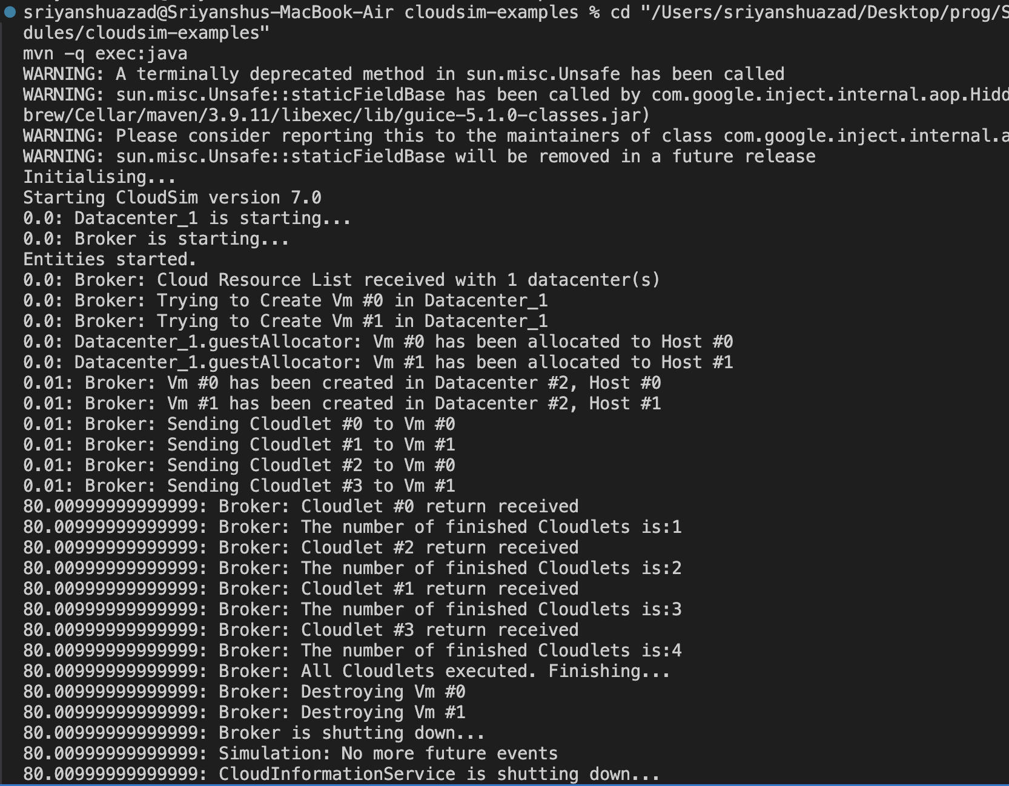
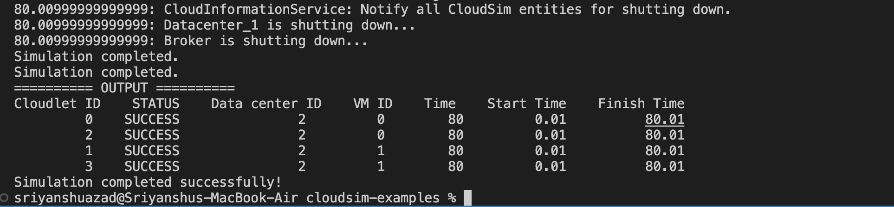
OUTPUT:

LEARNING OUTCOME:

